1.2 User journey map
We developed a six-stage user journey map as shown below:
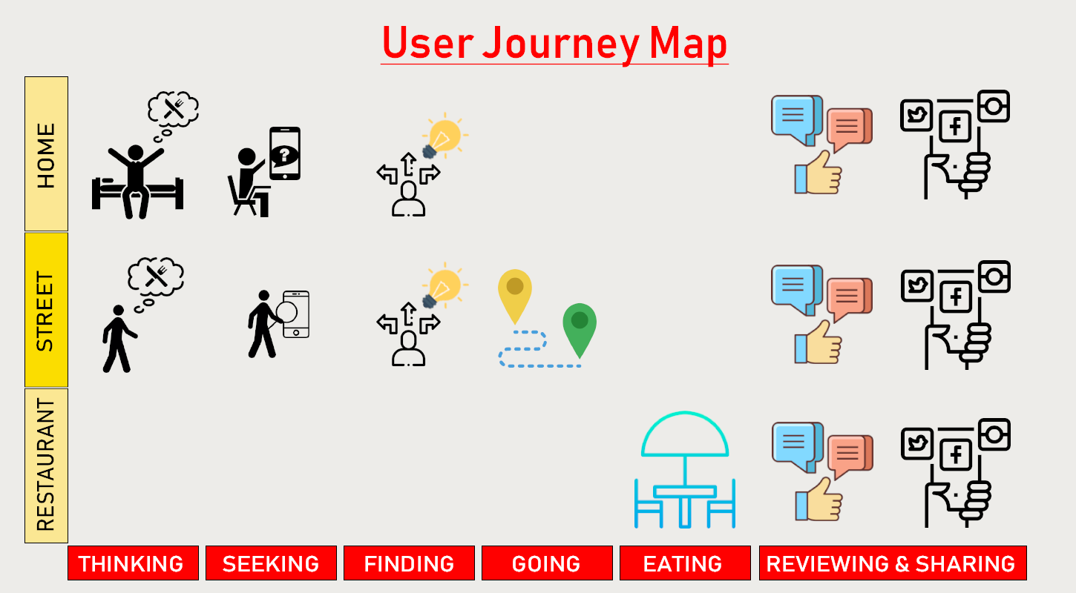
Thinking: It is when a user starts to think about eating out somewhere. It does not matter whether he is on the street or just at home, nor does he even necessarily feel hungry. He may want to get together with his friends in the coming days or just want to find himself a nice place to eat someday.

Seeking: If the user cannot come up with any idea after internal search, he may start to ask for advice from his friends or the Internet, which is the potential first touchpoint where Foodbulous should try every strategy it can (e.g. SEO/SEM, branding, marketing) to show out in front of the user. So the user will go to Foodbulous instead of going to competitors.

Finding: Depending on different situations, a user may want to add certain restaurants into his wishing list for future visit, or just go to a particular restaurant right now to fill his stomach. For the second case, deciding which restaurant to eat can be a tough time especially with friends because there are too many options out there and friends’ tastes should also be taken into consideration. This stage is crucial for Foodbulous to demonstrate the unique selling point and distinguish itself from other competitors. Since the goal is to speed up the user’s decision-making process, reliable recommendations and reviews from friends is an effective solution. Moreover, the food list created or stored by the user, the daily restaurant recommendation by the official, the labelled and categorized restaurants as well as the autocomplete system can make the process of restaurant choosing easier and faster. The food lists generated by friends are the best reference to catch friends’ taste and give them a surprise. Other information like discount, location and available seats will also influence user’s decision.

Going: After determining which restaurant to eat, the user needs to figure out how to get there. A map that shows a visually understandable route to the destination is very important. A long queue could let people down and leave. A booking function and a popular times chart (as following) will be helpful for people to decide when to set out.
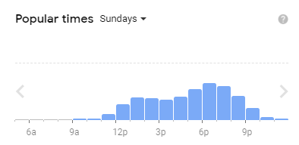
Source: Google Map
Eating: At this stage, the user has already found a seat in the restaurant. Before placing an order, the user may want to know which dishes are worth tasting. Foodbulous can provide advice by showing the user the most popular dishes of the restaurant and even support scan-code ordering. Ideally, user
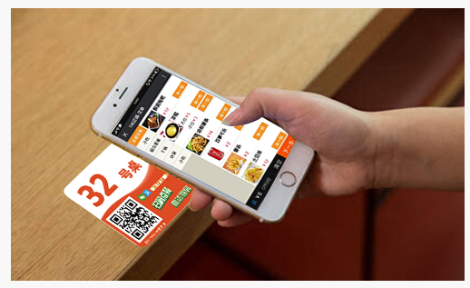
Source:大眾點評
pays after he has placed the order on the mobile.

Reviewing and Sharing: Actually, there is no a very clear chronological order between eating, reviewing and sharing, both could happen simultaneously. When the food is served, even before eating, the user may take photos and share it to social media. This is the last but not least touchpoint between Foodbulous and the user, where encouraging the user to write review is of vital importance to Foodbulous to maintain a sustainable platform ecosystem. Theoretically, a good ecosystem is supposed to guarantee money flows back to the creator. Therefore, there must be certain kinds of incentives to keep users contributing. Secondly, the process of writing reviews should be simplified to make it smooth for users while ensuring the content is reliable. A number of review templates could be worth trying and the report function is indispensable to prevent abuse.

